From Scientific Literature to Alloy Discovery: A Corpus–Topic–Document Framework for Copper Alloy Informatics
Zixuan Zhao¹, Zhikang Xie¹, Fei Tan¹, Peiyun Chen¹, Yanbin Jiang^{1*}, Tong Xie^{2,3*}, Wei Chen¹, Haoran Ouyang¹, Jing He¹,Wenqin Xu¹, Yanpeng Ye⁴, Guofu Xu¹, Byungju Lee^{5,6}, Zhou Li¹
1 School of Materials Science and Engineering, Central South University, Changsha, 410083, PR China.
2 School of Photovoltaic and Renewable Energy Engineering, University of New South Wales, Kensington, NSW, Australia.
3 Green Dynamics, Sydney, 2000, Australia.
4 Physical Sciences and Engineering Division, King Abdullah University of Science and Technology (KAUST), Thuwal 23955-6900, Saudi Arabia.
5 Department of Materials Science and Engineering, Korea University, Seoul, Republic of Korea
6 Nanoscience and Technology, KIST School, University of Science and Technology, Seoul, Republic of Korea.

* Corresponding authors: Yanbin Jiang ( jiangyanbin@tsinghua.org.cn ).
Tong Xie (tong.xie@unsw.edu.au).

Abstract：
High-quality Composition–Processing–Structure–Performance (CPSP) data infrastructures are essential for data-driven copper alloy discovery, yet relevant knowledge remains fragmented across textual descriptions, experimental tables, and graphical contents in scientific literature. To address this challenge, we propose a literature-centric Corpus-Topic-Document (CTD) framework transforming heterogeneous literature resources into machine-readable CPSP knowledge resources and machine learning (ML)-ready copper alloy databases. At the corpus level, semantic filtering is performed on 122,982 alloy-related publications, identifying 3,245 copper-alloy-relevant publications distributed across 457 semantic clusters. At the topic level, the filtered literature is organized into 7 interpretable thematic knowledge modules, revealing the semantic structure and temporal evolution of copper alloy research. At the document level, textual, tabular, and graphical information are reconstructed into machine-readable CPSP records through coordinated multi-modal processing. Using this framework, 9,284 high-quality CPSP data chains were reconstructed from full-text literature, with the best-performing model achieving token-level F1-scores above 0.90. Experimental validation of the optimized Cu–Ni–Si–Cr alloys achieved peak-aged properties of hardness 375 HV, tensile strength 1133 MPa , elongation ~8% , and conductivity 25.27 %IACS. Micro-structural characterization further confirmed the deformation-precipitation synergistic strengthening. The proposed framework establishes a hierarchical pathway from scientific literature to data-driven alloy discovery for artificial intelligence-enabled materials development.
Keywords: Copper alloy informatics; Corpus–Topic–Document framework; Literature knowledge utilization; Composition-Processing-Structure-Performance chain reconstruction; Large language models; Machine-learning-guided alloy design
Introduction:
In recent years, artificial intelligence-driven paradigms have profoundly transformed the research and development of metallic materials [1]. With the rapid advances in high-throughput computation, large language models (LLMs), and autonomous scientific discovery platforms, traditional trial-and-error-based materials development is gradually evolving toward data-driven and intelligent decision-making paradigms [2-4]. In this context, autonomous materials informatics systems capable of know-ledge acquisition, experimental planning, and performance optimization have become an important direction in advanced materials research. Among various metallic systems, high-performance copper alloys are widely used in integrated circuit lead frames, high-speed connectors, power electronics, new-energy transportation, and advanced manufacturing owing to their excellent electrical and thermal conductivity, corrosion resistance, and mechanical reliability. However, modern copper alloys are often required to simultaneously achieve high strength, high electrical conductivity, thermal stability, and long-term service reliability under harsh operating environments [5-6]. In particular, the relationships among composition, processing, micro-structural evolution, and performance in copper alloy systems are characterized by high dimensionality, strong nonlinearity, and complex Composition-Processing-Structure-Performance (CPSP) coupling. Therefore, data-driven copper alloy discovery requires literature-derived knowledge infrastructures capable of systematically organizing and utiliz-ing CPSP relationships across composition, processing, structure, and performance. [7-8].
However, extensive CPSP knowledge embedded in copper alloy literature is rarely available in unified, structured, and machine-readable forms [9]. Instead, it is widely scattered across scientific literature as textual descriptions, experimental tables, and graphical information. Key information on alloy composition, heat treatment, deformation, microstructural evolution, strengthening mechanisms, and mechanical properties is often embedded in experimental procedures, result discussions, figure captions, and mechanism analyses through non-standardized and context-dependent expressions. Meanwhile, variations in table layouts, hierarchical headers, and annotation styles further hinder cross-literature data alignment and reconstruction [10]. Graphical information, including microstructural images, diffraction patterns, and performance curves, contains essential evidence of microstructural evolution, phase transformation, and property responses. However, extracting such visual knowledge requires joint interpretation of image features, captions, axes, legends, and contextual semantics. Consequently, the fragmented and cross-modal nature of CPSP knowledge makes its systematic organization, semantic alignment, and effective utilization a critical challenge for copper alloy informatics and intelligent materials design [11-12].
From this perspective, scientific literature can be regarded as a hierarchical semantic knowledge space organized at the corpus, topic, and document levels [13]. At the corpus level, large-scale alloy literature corpora constitute a global knowledge space spanning diverse alloy systems and research domains, enabling the identification of copper-alloy-relevant knowledge from the broader materials literature landscape [14-16]. At the topic level, the filtered copper alloy literature is organized into interpretable thematic knowledge modules, such as strengthening mechanisms, corrosion behavior, thermo-mechanical processing, and microstructural evolution, thereby revealing semantic organization and knowledge topology of copper alloy [17-20]. At the document level, individual publications contain fine-grained CPSP knowledge distributed across text, tables, and graphical contents, requiring comprehensive reconstruction of CPSP relationships from heterogeneous multi-modal sources. Such a hierarchical Corpus–Topic–Document framework provides a new paradigm for systematically reconstructing and utilizing scientific literature knowledge, thereby bridging fragmented publications and data-driven alloy discovery [21-22].
Building upon these challenges, this work proposes a Corpus–Topic–Document framework for literature-driven copper alloy informatics. The framework is established based on 122,982 alloy-related publications collected from major scientific publishers, including Elsevier, Springer Nature, and the Royal Society of Chemistry, and progressively transforms fragmented literature knowledge into actionable CPSP resources through corpus-level discovery, topic-level organization, and document-level reconstruction. At the corpus level, BERTopic integrated with UMAP is employed to perform global semantic filtering and identify copper-alloy-related semantic regions from the broader alloy literature landscape containing multiple metallic systems [10,15-16]. At the topic level, 3,245 copper-alloy-related publications are further organized using Latent Dirichlet Allocation (LDA) to construct statistically coherent thematic structures and interpretable semantic knowledge modules [23]. At the document level, fine-grained CPSP knowledge is reconstructed from semantically selected copper-alloy literature fragments through collaborative textual, tabular, and graphical extraction pipe-lines. Specifically, large language models are used to extract implicit metallurgical knowledge from natural language [24-26], schema-constrained reconstruction is used for high-fidelity table parsing [27], and vision-language models are applied to categorize and interpret graphical information, including microstructural images, diffraction patterns, and performance curves [28-29].Through cross-modal semantic alignment and unified knowledge representation, the proposed framework progressively transforms fragmented scientific literature into ML-ready CPSP knowledge resources for machine-learning-guided copper alloy design [30-32]. From reconstructed CPSP resources, 9,284 ML-ready high-quality data records were further selected for downstream validation, enabling multi-objective prediction and optimization of strength and electrical conductivity in representative Cu-Ni-Si-based and Cu-Cr-based alloy systems. Experimental validation further demonstrated the rapid design capability of the proposed framework for high-strength and high-conductivity copper alloys based on 950,400 composition-processing feature combinations, while microstructural characterization further revealed that the exceptional strength-conductivity synergy originated from the coupled interaction between retained deformation substructures and nano-scale Ni₂Si precipitates. More importantly, this work demon-strates a complete pathway from scientific literature to alloy discovery by integrating hierarchical literature knowledge organization, multi-modal CPSP reconstruction, machine learning, and experimental validation [11, 25-33].
Materials and Methods：
- Literature Corpus Construction
To support literature-driven copper alloy informatics, a large-scale alloy literature corpus was construc-ted using the Web of Science advanced search platform with the retrieval keywords “Alloy”, “Cu”, and “Copper”. Publications from 2000 to 2025 were systematically collected from major scientific publishers, including Elsevier, the Royal Society of Chemistry (RSC), and Springer Nature. Metadata, including titles, abstracts, keywords, and DOIs, were batch extracted, resulting in an initial corpus of 122,982 publications. The raw corpus was then subjected to standardized pre-processing procedures, including stopword removal, terminology normalization, lemmatization, and duplicate elimination, to facilitate subsequent semantic filtering and knowledge organization [22,24]. Semantic filtering was then employed to identify copper-alloy-relevant studies while excluding semantically irrelevant publications, such as archaeology-related copper studies and non-engineering materials literature [36].
- Corpus-Level Semantic Filtering Based on BERTopic-UMAP
At the corpus level, the BERTopic-UMAP framework was employed to characterize different research directions while preserving semantic neighborhood relationships across related topics to reduce information loss caused by overly rigid filtering [15]. By integrating pre-trained language models with topic modeling, BERTopic enables high-resolution semantic clustering and relevance identification within the literature embedding space. Specifically, each publication d_{i} was first mapped into a high-dimensional semantic embedding vector e_{i} using a pre-trained language model (e.g., Sentence-BERT):
$e_{i }= f_{embed}(d_{i})$ (2.1)
Subsequently, Uniform Manifold Approximation and Projection (UMAP) was applied for nonlinear dimensionality reduction of the high-dimensional embedding vectors, generating low-dimensional semantic representations u_{i}:
$u_{i }= f_{UMAP}(e_{i})$ (2.2)
UMAP compresses the high-dimensional semantic space while preserving local neighborhood structures, thereby enabling the emergence of well-defined semantic clusters in low-dimensional space.
Based on these semantic embeddings, copper-alloy-relevant regions were identified from the broader alloy literature space, providing the corpus-level foundation for subsequent topic-level knowledge organization [16].
- Topic-Level Knowledge Organization Based on Latent Dirichlet Allocation
Latent Dirichlet Allocation (LDA) is a classical probabilistic generative topic model, assuming each publication is generated from a mixture of multiple latent topics, while each topic corresponds to a probability distribution over vocabulary [23]. For a given document corpus, the joint probability distribution can be expressed as:
(2.3)

where ω denotes the observed word set, z represents topic assignments, θ and ϕ correspond to the document-topic and topic-word distributions, respectively, α and β are Dirichlet hyper-parameters.
In this study, LDA was employed to organize the filtered copper alloy literature into interpretable thematic knowledge modules. The optimal number of topics was determined using the topic coherence score, enabling identification of the major research themes and their semantic relationships within the copper-alloy domain. This process reveals topic-level knowledge distribution of copper alloy research and provides an organized semantic structure for subsequent document-level CPSP reconstruction and downstream alloy design.
- Multi-modal CPSP Extraction Performance Evaluation
To quantitatively evaluate the performance of multi-modal CPSP extraction, multiple metrics, includ-ing accuracy, precision, recall, F1-score, and BLEU score, were employed [37]. Accuracy, precision, recall, and F1-score are defined as follows:
$Accuracy= \frac{TP + TN}{TP + TN + FP + FN}$ (2.4)
$Precision= \frac{TP}{TP + FP}$ (2.5)
$Recall= \frac{TP}{TP + FN}$ (2.6)
$F1−score= \frac{2 × Precision × Recall}{Precision + Recall}$ (2.7)
Here, the ground truth refers to manually verified reference annotations established from expert-labeled expert-labeled CPSP records. Here, the ground truth refers to manually verified reference annotations established from expert-labeled CPSP records. Specifically, a benchmark dataset contain-ing 453 records was manually annotated by 3 materials science researchers. All annotations were independently checked by 2 researchers and finally verified by a senior materials expert. The annotations covered composition, processing, structure, performance, and strengthening mechanisms. Based on the comparison between model-generated outputs and the ground truth database, TP denotes correctly identified target entities, TN represents correctly excluded non-target cases, FP corresponds to incorrectly generated or misidentified entities, and FN indicates relevant entities that were not successfully extracted. Accuracy evaluates the overall agreement between predicted results and reference annotations, precision reflects the reliability of extracted positive entities, recall measures the ability of the framework to capture relevant information, and F1-score provides a comprehensive evaluation by balancing precision and recall. For textual and tabular extraction, both character-level and token-level metrics were calculated, whereas image-based extraction was evaluated using classification-oriented accuracy, precision, recall, and F1-score. In addition, the BLEU score was employed to assess sequence-level similarity between generated outputs and reference annotations, particularly for evaluating structural and semantic consistency in CPSP reconstruction tasks.
5. Machine-Learning-Guided Alloy Design and Experimental Validation
To validate the practical applicability of the proposed Corpus–Topic–Document framework for alloy discovery, machine-learning-guided design and experimental investigations were conducted on Cu–Ni–Si–Cr alloys targeting synergistic optimization of strength and electrical conductivity. A total of 950,400 composition–processing combinations were virtually screened using the trained machine learning models, rather than experimentally fabricated. These candidate combinations followed the processing route of “Solution → Quenching → Deformation → Aging → Secondary Thermo-Mechanical Processing (TMP) → Secondary Aging”. The composition design space included Ni (4–6 wt%), Si (1–2.5 wt%), Cr (0.1–0.3 wt%), and optional microalloying additions of Al (0.3–0.5 wt%) and Mg (0.01–0.16 wt%). Although Al and Mg were included in the composition design space during virtual screening, machine-learning predictions indicated that the highest-ranked candidates were located within the Cu–Ni–Si–Cr compositional subspace. Therefore, experimental validation was conducted on the top-performing Cu–Ni–Si–Cr candidates. The processing parameter space included solution treatment at 900–1000 °C for 3–7 h and aging treatment at 300–550 °C for 0.5–5 h. The optimal alloy candidates were identified using the normalized comprehensive performance index Q3-Euclidean, defined as:
$Q3−Euclidean=\sqrt{\text{(}\frac{{HV−{HV}_{\text{min}}}^{ }}{{HV}_{\text{max}}−{HV}_{\text{min}}})^{2}+{(\frac{{EC−{EC}_{\text{min}}}^{ }}{{EC}_{\text{max}}−{EC}_{\text{min}}}\text{)}}^{2}}$ (2.8)
where HV and EC represent the hardness and electrical conductivity of a candidate alloy, respectively. HV_{min}, HV_{max}, EC_{min}, and EC_{max} correspond to the minimum and maximum values of hardness and electrical conductivity in the virtual screening database.Therefore, a larger Q3-Euclidean value indicates a greater simultaneous improvement in hardness and electrical conductivity relative to this low-performance reference state [38-39]. For hardness evaluation, Vickers hardness testing was conducted using an HV-1000 tester under a load of 500 g with a dwell time of 15 s. For electrical conductivity measurement, testing were performed at 25 °C using a digital eddy-current conductivity meter, and the reported values represent the average of five measurements. For mechanical property evaluation, tensile testing was conducted using a universal testing machine (AG-250KINS) with three repeated tests for each alloy condition.For microstructural characterization, field-emission transmiss- ion electron microscopy (TEM, G20) was employed to analyze the microstructural evolution and precipitation behavior of the optimized alloys.
Results
1. Overview of the Corpus–Topic–Document Framework for Copper Alloy Informatics
As illustrated in Fig.1a, the proposed Corpus–Topic–Document framework for copper alloy infor-matics consists of five main stages: (i) multi-modal literature corpus construction, (ii) corpus-level semantic filtering and relevance identification, (iii) topic-level knowledge organization, (iv) document-level fine-grained CPSP reconstruction, and (v) ML-ready knowledge resource construction and downstream alloy design validation. This workflow follows a hierarchical knowledge representation paradigm, progressively transforming heterogeneous scientific literature into structured and machine-readable CPSP knowledge resources for subsequent modeling, optimization, and alloy discovery. At the initial stage, the framework starts from a large-scale corpus of 122,982 literature from the broader alloy materials domain, encompassing multiple alloy systems, including copper alloys, aluminum alloys, high-entropy alloys, and Ni-based alloys. It is noteworthy that, even when using “copper alloy” as the primary query in Web of Science and relateddatabases, keyword-based retrieval cannot strictly isolate copper-alloy-focused studies. Due to overlapping terminology and shared research contexts, the retrieved corpus inevitably contains semantically related but compositionally different material systems, where copper may appear as an alloying element, substrate, catalyst component, or corrosion-related species rather than the primary alloy system under investigation. As a result, the initial corpus forms a generalized alloy semantic space rather than a strictly isolated copper alloy dataset, requiring corpus-level semantic filtering before downstream knowledge organization. Within this literature space, multi-modal information, including text, tables, and images, serves as the primary raw information source for subsequent CPSP reconstruction.However, these heterogeneous inputs encode critical materials knowledge, such as processing conditions and structural evolution, in different formats and therefore cannot be directly used for data-driven modeling. Therefore, corpus-level semantic modeling based on BERTopic with UMAP dimensionality reduction was applied to identify copper-alloy-relevant regions within the broader alloy literature space, thereby mapping the generalized corpus into a copper-alloy-relevant subspace. In this framework, BERTopic-UMAP is used primarily for high-resolution corpus-level relevance identification rather than final thematic interpretation. After corpus-level filtering, LDA was introduced for topic-level knowledge organization of the copper-alloy-relevant corpus, providing a more interpretable representation of dominant research themes and their relative contributions within the copper alloy domain. Thus, BERTopic-UMAP and LDA operate at different semantic solutions: BERTopic-UMAP identifies fine-grained copper-alloy-relevant semantic neighborhoods from broader WOS-derived alloy corpus, whereas LDA summarizes the filtered corpus into high-level thematic knowledge modules. This step transforms the filtered corpus into an organized topic-level knowledge space, where topics such as corrosion behavior, strengthening mechanisms, and microstructural evolution are represented as interpretable know-ledge modules linking relevance identification with structured domain understanding. Subsequently, at the document level, the framework performs fine-grained CPSP reconstruction on a per-publication basis through a tri-track multi-modal extraction mechanism, including textual, tabular, and graphical pipelines. The textual pipeline leverages large language models to extract implicit metallurgical knowledge embedded in natural language fragments. The tabular pipeline applies rule-based parsing and schema-based mapping strategies to retrieve high-precision numerical data from heterogeneous tables. The graphical pipeline classifies and interprets microstructural images (SEM, TEM, OM, and EBSD), diffraction patterns (XRD pattern, SAED), performance curves (line charts, stress-strain/ hardening curves), and statistical plots (histograms, bar charts, and scatter plots) to capture visual evidence of structural evolution and property responses. By integrating these complementary modalities, the framework constructs structured CPSP data chains with unified representations. In the final step, the reconstructed CPSP data chains are integrated into ML-ready copper alloy knowledge resources, supporting downstream tasks such as property prediction, multi-objective optimization, and experimental validation, as shown in Fig. 1a. As illustrated in Fig. 1b, the workflow can be interpreted as a unified representation-space transformation from raw literature resources to ML-ready CPSP knowledge representations. Along the horizontal axis, information flows from the multi-modal literature space to corpus-level relevance selection, topic-level knowledge organization, document-level CPSP representation, and finally the predictive model space. Along the vertical axis, different categories of materials information, including composition, processing, structure, and properties, are systematically encoded into a unified attribute space, ensuring consistency across heterogeneous modalities.Within this two-dimensional representation, multi-modal inputs are first decomposed into semantic units, then organized through corpus- and topic-level semantic structures, and ultimately mapped into CPSP-aligned data chains.
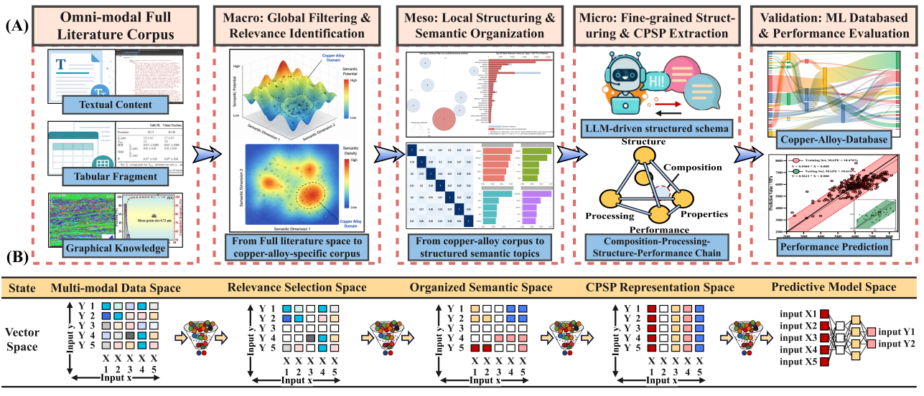
Fig. 1. Overview of the proposed Corpus–Topic–Document framework for literature-driven copper alloy informatics. (A) Schematic illustration of the end-to-end workflow, consisting of multi-modal literature corpus construction, corpus-level semantic filtering and relevance identification, topic-level knowledge organization, document-level fine-grained CPSP reconstruction, and ML-ready knowledge resource construction for downstream performance prediction and alloy design. (B) Hierarchical representa-tion of information transformation within the CTD framework, where literature information is progressively organized from multi-modal data to structured CPSP resources along the horizontal axis, while composition, processing, structure, and property information are continuously aligned across different representation spaces along the vertical axis.

2. Corpus–Topic Semantic Organization: From Literature Filtering to Knowledge Structuring
To address ambiguous semantic boundaries in keyword-retrieved alloy literature, corpus-level semantic filtering was performed using BERTopic on the large-scale alloy literature corpus. The proposed approach constructs follows hierarchical pipeline “Corpus construction → Semantic embedding → Dimensionality reduction → Density-based clustering → Topic reconstruction → Visualization mapping”, enabling the systematic transformation of the unstructured literature into an interpretable semantic space capturing the organization of diverse alloy research themes. Specifically, publication-level representations were construct-ed by integrating titles, abstracts, author keywords, and keywords plus. These texts were then mapped into a high-dimensional semantic embedding space using the pre-trained SentenceTransformer model all-mpnet-base-v2, with normalization applied to enhance semantic consistency. Subsequently, a decoupled clustering–visualization strategy was used, in which dimensionality reduction supported density-based clustering, while a separate two-dimensional UMAP projection (UMAP-1: -7.899~11.883; UMAP-2: -7.382~10.856) was used only for visualization. The two-dimensional projection was interpreted as a visualization of local semantic neighborhoods rather than as direct evidence of global semantic distances. For clustering, HDBSCAN was applied within BERTopic to identify semantically coherent publication clusters based on local density patterns in the embedding space. Topic representations were then refined using BERTopic’s c-TF-IDF, yielding more representative and interpretable keywords for each cluster. For visualization, an additional distance-based filtering step was applied to remove peripheral points far from central clusters, improving the compactness and visual clarity of the topic map.
As shown in Fig. 2A, the BERTopic–UMAP analysis reveals a heterogeneous yet structured corpus-level semantic distribution within 122,982 alloy-related publications. A total of 457 non-noise BERTopic clusters were identified, with the largest cluster accounting for only 2.57% (3,163 publications), while the remaining clusters exhibited a long-tail distribution. These clusters were used as fine-grained semantic neighborhoods for relevance identification rather than as final high-level research topics. Distinct semantic regions form dense local aggregations in the two-dimensional UMAP projection, suggesting locally coherent semantic neighborhoods. Because UMAP primarily preserves local neighborhood structures and may distort global distances, visual proximity in the projection was not used alone as evidence of semantic overlap. A closer look at the copper-related regions in Fig. 2B shows that copper-alloy-relevant studies are not confined to a single cluster but are distributed across multiple thematic domains, including Mechanics (clustering 8), Corrosion (clustering 6), High-Entropy Alloys (clustering 18), Irradiation (clustering 15), and Shape Memory Alloys (clustering 2). Building upon the corpus-level semantic filtering, Fig. 2C-D, Fig. 3A-D, and Table 1 further characterize topic-level knowledge structure, statistical validity, and semantic composition of the copper-alloy-relevant corpus using LDA. Fig. 2D further illustrates the temporal evolution of major research themes from 2020 to 2025. While structure-property-related studies remained consistently dominant, topics such as corrosion, deposition, and interfacial reactions exhibited varying levels of growth and decline, indicating dynamic shifts in research priorities within the copper-alloy field. Detailed trend analyses of publishers, journals, institutions, keywords, and funding agencies are provided in Supplementary Figure 1. As shown in Fig. 3A, the coherence score reaches its maximum when the topic number is seven, indicating that seven topics provide the most semantically consistent representation of the filtered copper-alloy corpus. Based on that, the topic distribution in Fig. 2C shows a structured yet non-uniform pattern, where dominant themes such as structure-property relationships, corrosion, deposition, interfacial reactions, and amorphous/alloy systems, occupied center of the knowledge landscape. This is consistent with the topic weight distribution in Fig. 3B, which shows uneven contributions, with several dominant topics accompanied by smaller but meaningful topics, forming a clear long-tail structure.
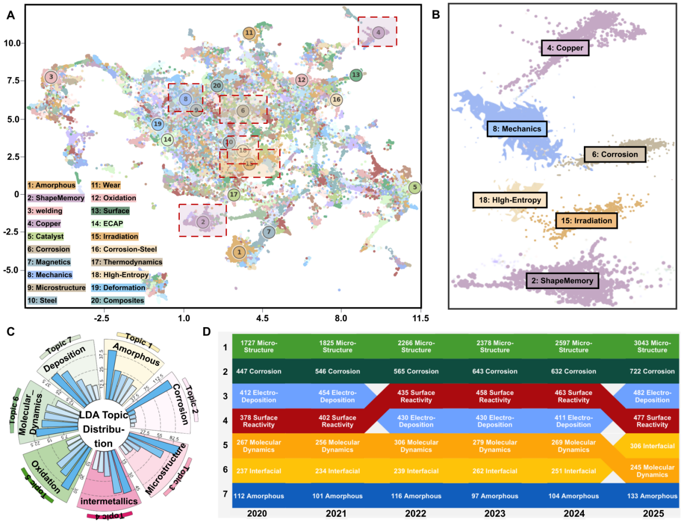
Fig. 2. Corpus–Topic semantic organization of alloy literature using BERTopic-UMAP and LDA. (A) UMAP visualization of the corpus-level alloy semantic space constructed from 122,982 publications, where each point represents a publication and colors indicate BERTopic-derived semantic clusters. (B) Enlarged view of representative corpus-level semantic regions, highlighting the distribution of copper-related studies across multiple domains. (C) LDA-based topic distribution, illustrating the hierarchical organization of major research themes and their relative proportions within the corpus. (D) Temporal evolution of topic distributions over 2020–2025, illustrating changes in research focus across major copper-alloy-related themes.

Furthermore, Fig. 2D and Fig. 3D reveal the temporal evolution of research focus and its underlying keyword-level semantic basis. Structure-related studies consistently maintain a high proportion, under-scoring their central role in copper alloy research, while topics such as corrosion, surface reactions, electrodeposition, molecular dynamics, and interfacial phenomena exhibit noticeable temporal variations. This trend is further supported by the keyword distribution in Fig. 3D, where terms such as microstructure, mechanical properties, corrosion, precipitation, and strength define the core semantic regions. Overall, these results suggest that copper alloy research is increasingly organized around coupled structure–property relationships, multi-mechanism strengthening, and multi-scale investigations. The inter-topic similarity heatmap in Fig. 3C indicates low-to-moderate correlations, suggesting that the LDA topics are generally distinguishable while maintaining limited semantic connections. Overall, these results show that LDA organizes the filtered corpus into interpretable topic-level knowledge modules while capturing the statistical and temporal dynamics of copper alloy research, thereby linking corpus-level semantic filtering with subsequent document-level CPSP reconstruction.

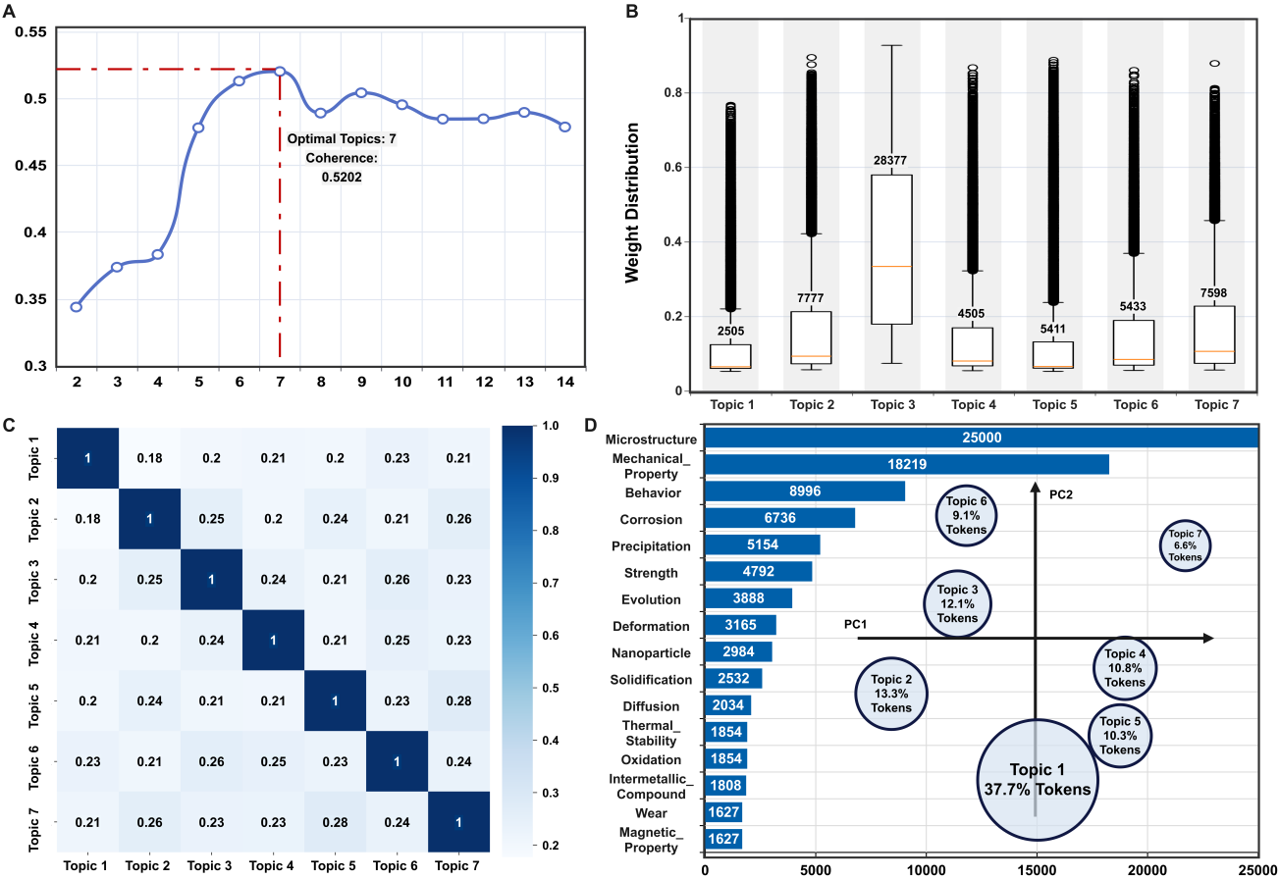
Fig. 3. Topic-level knowledge organization and statistical characteristics of the copper-alloy-relevant literature corpus. (A) Variation of coherence score with the number of topics, indicating an optimal topic number of 7. (B) Topic weight distribution, reflecting the relative contributions of different topics within the corpus. (C) Topic correlation matrix, illustrating the semantic relationships among topics. (D) Keyword frequency distribution and two-dimensional projection of topics in the principal component space, where circle size represents the proportion of each topic in the corpus.

Table 1. LDA topic probability distribution of the copper alloy literature corpus
Topic | Topic Contents | Probability
Topic 1 | 0.041*"Thermal_stability" + 0.030*"Metallic_glass" + 0.025* "Magnetic_property" + 0.023*"Crystallization" + 0.023*" Amorphous_ alloy" + 0.022*"Cu" + 0.022*"Bulk_metallic_ glass" + 0.020* "High_ entropy_alloy" + 0.019*"Glass_ forming_ ability" + 0.012* "Plasticity" | 6.67%
Topic 2 | 0.074*"Corrosion" + 0.054*"Copper" + 0.026*"Alloy" + 0.025* "Corrosion_resistance" + 0.019*"Resistance" + 0.018*"Wear" + 0.016*" Coating" + 0.015*"Behavior" + 0.012*"Copper_alloy" + 0.012*"Steel" | 13.35%
Topic 3 | 0.095*"Microstructure" + 0.071*"Mechanical_properties" + 0.039* "Alloy" + 0.030*"Behavior" + 0.020*"Precipitation" + 0.019*" Strength" + 0.016*"Copper" + 0.015*"Evolution" + 0.013*" Aluminum_alloy" + 0.012*"Deformation" | 36.61%
Topic 4 | 0.028*"Cu" + 0.026*"Interface" + 0.026* "Intermetallic_ compound" + 0.025*"Joint" + 0.022*"Alloy" + 0.021*" Shape_memory_alloy" + 0.019*"Solder" + 0.019*"Inter-metallic" + 0.019*"Stainless_steel" + 0.017*"Interfacial_ reaction" | 10.22%
Topic 5 | 0.040*"Catalyst" + 0.032*"Nanoparticle" + 0.025* "Oxida- tion" + 0.019*"Copper" + 0.016* "Electrocatalyst" + 0.015* "Reduction" + 0.012*"Alloy" + 0.012*"Cu" + 0.011* "Perfor-mance" + 0.011*" Surface" | 8.9%
Topic 6 | 0.038*"Alloy" + 0.021*"Solidification" + 0.019*"System" + 0.018* "Diffusion" + 0.017*"Molecular_dynamics" + 0.017* "Segregation" + 0.015*"Growth" + 0.013*"Simulation" + 0.013*" Cu" + 0.012* "Iron" | 11.11%
Topic 7 | 0.039*"Copper" + 0.026*"Alloy" + 0.024*"Electrodeposition" + 0.023*"Cu" + 0.021*"Fabrication" + 0.018*"Film" + 0.016* "Thin_film" + 0.014*"Deposition" + 0.014*" Mechanical_ alloying" | 13.15%

- Document-level: Fine-grained multi-modal CPSP reconstruction
At the document level, fragmented alloy knowledge distributed across text, tables, and literature figures is reconstructed into machine-readable CPSP data chains through a tri-track multi-modal extraction architecture, consisting of textual, tabular, and visual processing pipelines (Fig.4). The collected XML/ HTML full texts were first parsed into hierarchical section–paragraph structures and transformed into machine-readable JSON representations containing section identifiers, titles, and paragraph-level semantic units. Subsequently, rule-based semantic segmentation and structured-prompt-guided LLM extraction were combined to reconstruct fragmented metallurgical descriptions into schema-aligned CPSP records, transforming composition, processing, structure, property, and strengthening-mechanism information into hierarchical “entity–condition–attribute–value” relationships. The tabular pipeline reconstructs structured CPSP information from heterogeneous XML/HTML tables by converting publisher-specific table formats into standardized representations preserving relationships among titles, headers, and cell entries. Abnormal-output validation is further employed to identify formatting errors, semantic inconsistencies, and halluci-nated entries, thereby improving extraction reliability.

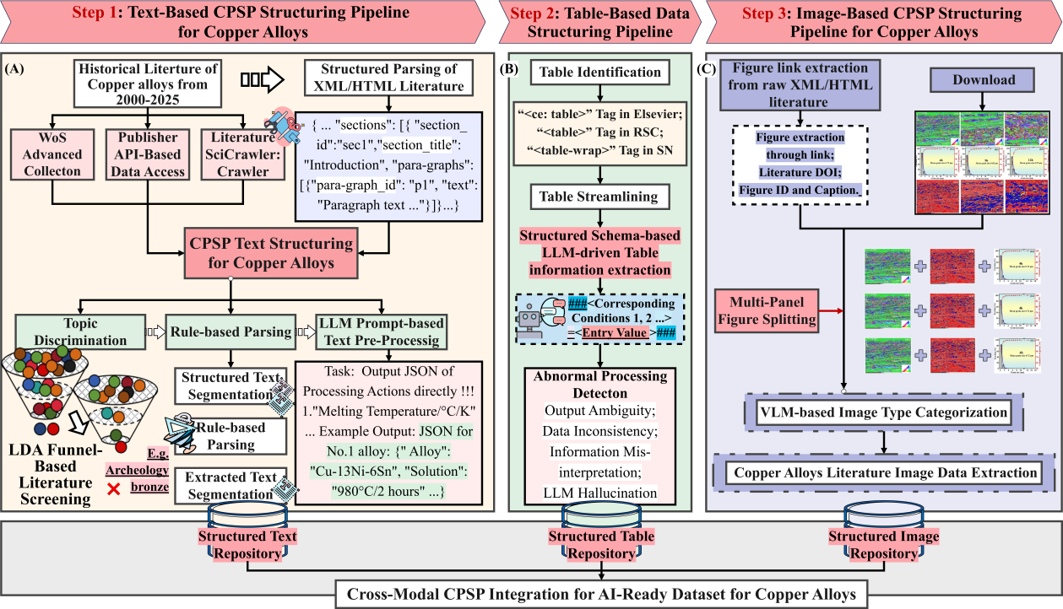
Fig. 4. Document-level multi-modal CPSP reconstruction framework for copper alloys: (A) Text-based CPSP structuring pipeline for transforming unstructured metallurgical descriptions into machine-readable CPSP records. (B) Table-based structuring pipeline for reconstructing structured CPSP information from heterogeneous literature tables. (C) Image-based structuring pipeline for organizing literature figures, including microstructural images, diffraction patterns, statistical plots, and performance curves. Structured text, table, and image resources are subsequently integrated into a unified CPSP-oriented copper alloy repository.

The CPSP image structuring pipeline further extends the framework to literature figure extraction and categorization. Figure links, captions, and metadata are first extracted from XML/HTML literature, followed by automated image downloading and multi-panel figure splitting. Subsequently, VLM-based image cate-gorization is employed to classify different literature image resources, including micro-structural images (e.g., SEM, TEM, EBSD, OM), diffraction patterns (e.g., XRD, Selected Area Electron Diffraction), schematic mechanism diagrams, statistical plots such as scatter plots, line charts, histograms, and bar charts, and performance curves (line charts, stress-strain/hardening curves). Based on the categorized image resources, quantitative information from statistical plots and line charts is further extracted and converted into structured numerical representations using an “x/y-axis–attribute–value” format. These figure-level records are linked to the corresponding publication, figure caption, alloy system, and property category when such condition-value pairs are available. The processed visual resources and extracted figure-level information are finally stored in the structured image repository. Finally, structured text-, table-, and figure-level outputs are organized into a unified copper alloy repository through schema-level harmonization and shared identifiers, including publication DOI, alloy system, composition, processing route, processing conditions, performance metrics, and strengthening mechanisms. This repository-level integration enables traceable CPSP record construction and provides a unified knowledge foundation for downstream data-driven modeling, property prediction, and alloy design.

- Validation of Document-Level Multi-Modal CPSP Reconstruction
To systematically evaluate the performance of the fine-grained multi-modal CPSP reconstruction framework for copper alloys, benchmark evaluations were conducted using representative LLMs and VLMs on a manually annotated ground-truth dataset. For text- and table-based CPSP extraction, the ground-truth benchmark consisted of 506 manually annotated CPSP records containing 2737 annotated entities and 256 heterogeneous tables with diverse layouts and publisher-specific structures. All annotations were independ-ently verified by 3 domain experts prior to evaluation.For image-based evaluation 372 manually annotated scientific figures covering nine image categories were used for benchmark testing. As shown in Fig. 5A–F, the extraction performance was evaluated across six categories, including composition, processing, structure, performance, strengthening mechanisms, and tabular information, using character- and token-level metrics, including accuracy, precision, recall, F1-score, and BLEU. Overall, GPT-4-1106-preview achieved the best performance across most evaluated text- and table-based CPSP categories, with token-level F1-scores generally exceeding 0.90. Claude-3-Haiku and GPT-4o-mini showed competitive performance, whereas lightweight models such as Moonshot-v1-32k and Spark-4.0-Ultra exhibited noticeable degradation in semantically complex tasks, especially structure and strengthening-mechanism extraction. Across different metrics, precision tended to be higher than recall, indicating that most models were relatively conservative and more likely to omit relevant entities than to extract incorrect outputs. Therefore, variations in F1-score were primarily influenced by recall degradation in loosely structured textual contexts, such as mechanism descriptions and multi-step processing routes. BLEU showed larger fluctuations than token-level metrics, reflecting its sensitivity to wording variations and sequence-level structural differences in generated outputs.
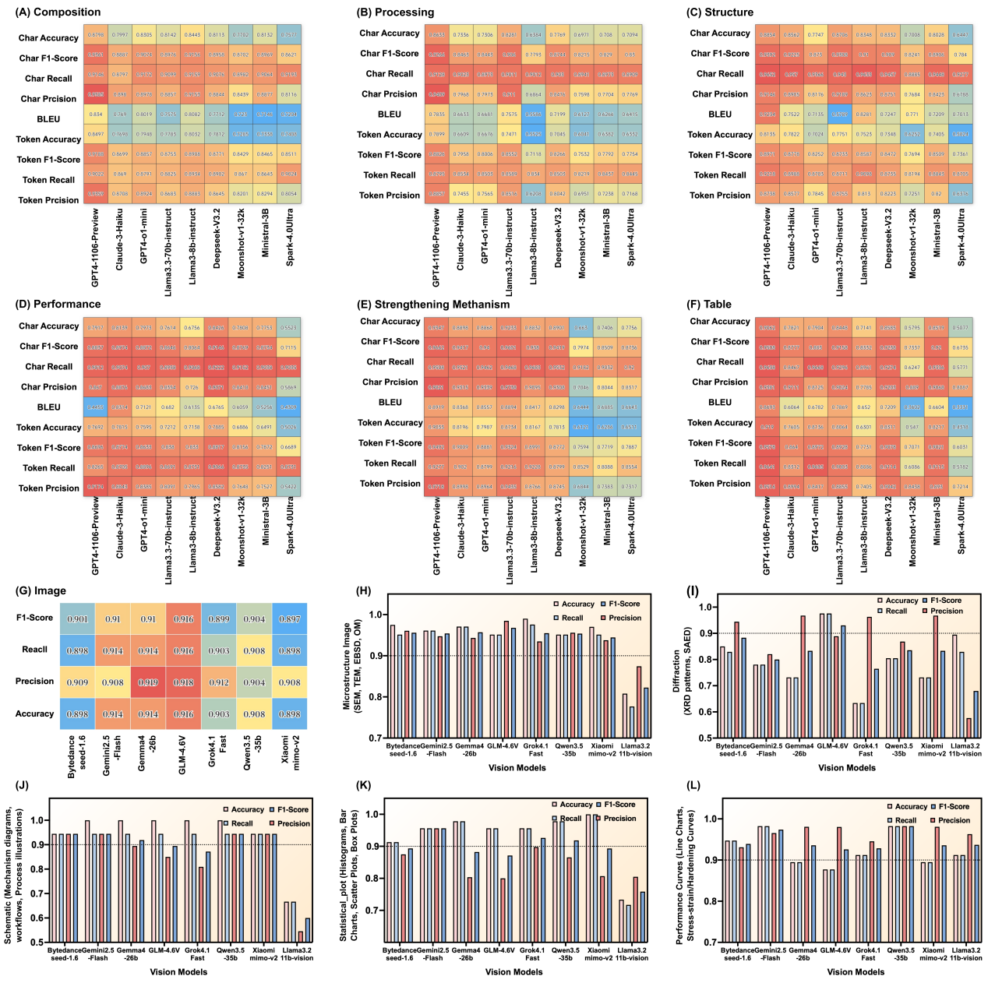
Different CPSP categories also exhibited distinct extraction characteristics. Composition information achieved the highest overall performance because of its explicit numerical expressions, standardized alloy formulas, and elemental names. Processing-related information maintained relatively high precision but comparatively lower recall, mainly owing to nested thermo-mechanical conditions and multi-step processing dependencies. Structural and performance information exhibited larger inter-model differences because such descriptions often contain implicit semantic relationships, qualitative expressions, and diverse metallurgical terminology. Extraction of strengthening mechanisms showed significant variability among models, suggest-ing that mechanism descriptions remain challenging for lightweight LLMs because of their highly abstract semantic characteristics. For tabular extraction, GPT-4-1106-preview and Claude-3-Haiku maintained high token-level accuracy and precision despite heterogeneous publisher-specific layouts and table structures. In contrast, lightweight models such as Spark-4.0-Ultra exhibited more pronounced performance degradation for irregular tables. Moreover, recall degradation was still observed in tables containing omitted headers, and irregular merged structures, indicating that complex logical dependencies in tables remain a major source of extraction uncertainty.
Fig. 5 Benchmark evaluation of LLMs for text- and table-based CPSP extraction and VLMs for scientific figure categorization.(A-F) Heatmap comparison of text- and table-based extraction performance across six CPSP-related categories, including composition, processing, structure, performance, strengthening mechanism, and tabular information. (G) Overall categorization performance of representative VLMs for literature figure understanding. (H-L) Category-level evaluation of VLM-based figure categorization tasks, including microstructural images (SEM, TEM, EBSD, OM), diffraction patterns (XRD plots and SAED patterns), schematic mechanism diagrams, statistical plots (histograms, bar charts, and box plots), and performance curves (line charts and stress-strain/hardening curves).

Beyond textual and tabular modalities, VLM-based evaluation was conducted for literature image understanding. As shown in Fig. 5(G), most VLMs achieved overall accuracies above 0.90, indicating robust capability in coarse-grained scientific image categorization. However, fine-grained results in Fig. 5(H-L) reveal clear modality-dependent differences. Microstructural images, including scanning electron micro-scopy (SEM), transmission electron microscopy (TEM), electron back-scatter diffraction (EBSD), and optical microscopy (OM) images, showed relatively balanced accuracy, precision, recall, and F1-score, mainly because their texture, morphology, and contrast features are visually distinctive. Statistical plots (histograms, bar charts, scatter plots, box plots) and performance curves (line charts, stress-strain/hardening curves) also achieved stable extraction performance, as their axes, legends, markers, and curve shapes provide regular graphical cues for recognition. In contrast, diffraction-pattern-related tasks, including X-ray diffraction (XRD) plots and selected area electron diffraction (SAED) patterns, exhibited the significant performance fluctuations, with recall often lower than precision. This is mainly because diffraction patterns usually occupy relatively small regions within literature figures and frequently co-exist with SEM/TEM microstructural images, making their visual boundaries and semantic categories more difficult for VLMs to distinguish accurately. Schematic diagrams also showed moderate instability because they often combine arrows, labels, process routes, and symbolic illustrations, requiring higher semantic reasoning rather than simple visual pattern recognition. Overall, image extraction performance is strongly influenced by the visual characteristics and semantic abstraction of different figure types. The results demonstrate the feasibility of multi-modal CPSP knowledge reconstruction from large-scale materials literature while revealing clear performance variations across different models and modalities.

5. Downstream Validation: Rapid Data-Driven Copper Alloy Design Enabled by ML

5.1 Data-Driven Feature Engineering and Multi-objective Prediction of Copper Alloys
To evaluate the applicability of the reconstructed CPSP resources for data-driven copper alloy design, 3,358 CPSP records were selected from 9,284 ML-ready data chains by retaining samples with comparable thermo-mechanical processing histories following the route of “Solution → Quenching → Deformation → Aging → Secondary TMP → Secondary Aging” across representative Cu–Ni–Si- and Cu–Cr-based alloy systems. Based on these data, multi-objective machine-learning (ML)models were developed for hardness, electrical conductivity and Q3-Euclidean prediction, while the CPSP-oriented feature engineering workflow was employed to identify key descriptors governing composition–processing–structure–performance relationships. The dataset was randomly divided into training and testing subsets using an 8:2 ratio, with the testing set reserved for independent evaluation. Within the feature engineering stage, a three-step CPSP-oriented feature screening strategy consisting of correlation filtering, permutation-importance refinement, and combinational optimization was employed to identify key factors governing multi-objective properties in these copper alloy systems [4,40]. As shown in Fig. 6A–6C, Pearson correlation analysis was first performed on the training set to identify features correlated with the target properties from composition-, thermodynamic-, processing-, and physicochemical-related feature spaces, while excluding weakly relevant and redundant variables. Subsequently, recursive feature refinement based on permutation importance and statistical contribution analysis was applied within training set to iteratively eliminate low-contribution features and construct more compact and representative feature subsets (Fig. 6D–6F). Finally, exhaustive combinational searches were performed over the remaining feature subsets to determine the optimal feature combinations by minimizing cross-validation prediction errors within the training set (Fig. 6G–6I). Feature engineering results reveal pronounced target-dependent heterogeneity in CPSP relationships, which is further supported by the SHAP analyses shown in Fig. 7A–C. Hardness is mainly governed by deformation-related parameters, Ni/Si ratio, and precipitation-associated thermodynamic descriptors, highlighting the importance of precipitation evolution and microstructural regulation. In contrast, electrical conductivity is more strongly influenced by aging conditions, elemental concentrations, and electron-scattering-related descriptors, reflecting the effects of solute depletion and phase stability on electron transport. As a coupled metric integrating hardness and conductivity, the Q3-Euclidean index is governed by a broader combination of compositional, processing, and thermodynamic features, indicating that balanced performance arises from coupled CPSP interactions rather than a single controlling factor.

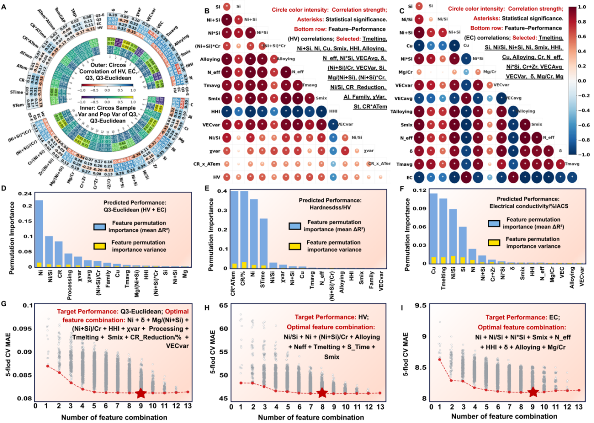
Fig.6. Three-step CPSP-oriented feature selection strategy for downstream machine learning. (A-C) Pearson correlation filtering for Q3-Euclidean, hardness, and electrical conductivity, performed on the training set to remove weakly correlated or redundant features. (D-F) Permutation-importance-based recursive feature refinement for identifying key descriptors associated with each target property. (G-I) Exhaustive search of the remaining feature combinations, showing the variation of mean absolute error (MAE) with feature subset size and the resulting optimal feature subsets.

Based on the optimized feature subsets, model performance was further evaluated across representative Cu–Ni–Si–Al–Cr–Mg, Cu–Cr, Cu–Cr–Ni–Si, and Cu–Ni–Si alloy systems. As shown in Fig. 7D–7R, the proposed CPSP-oriented framework achieved generally good predictive performance for hardness, electrical conductivity, and Q3-Euclidean, although noticeable variations remained among different alloy systems and target properties. For hardness, most models achieved high accuracy with small training–testing gaps, demonstrating good predictive stability, especially for Cu-Cr and Cu-Cr-Ni-Si datasets. Larger deviations were observed for Cu-Ni-Si and Cu-Ni-Si-Al-Cr-Mg systems. Electrical conductivity generally achieved lower MAE values and more consistent prediction performance across different datasets, whereas Q3-Euclidean prediction showed greater variability among models and alloy systems, highlighting the increased complexity of simultaneously optimizing hardness and electrical conductivity
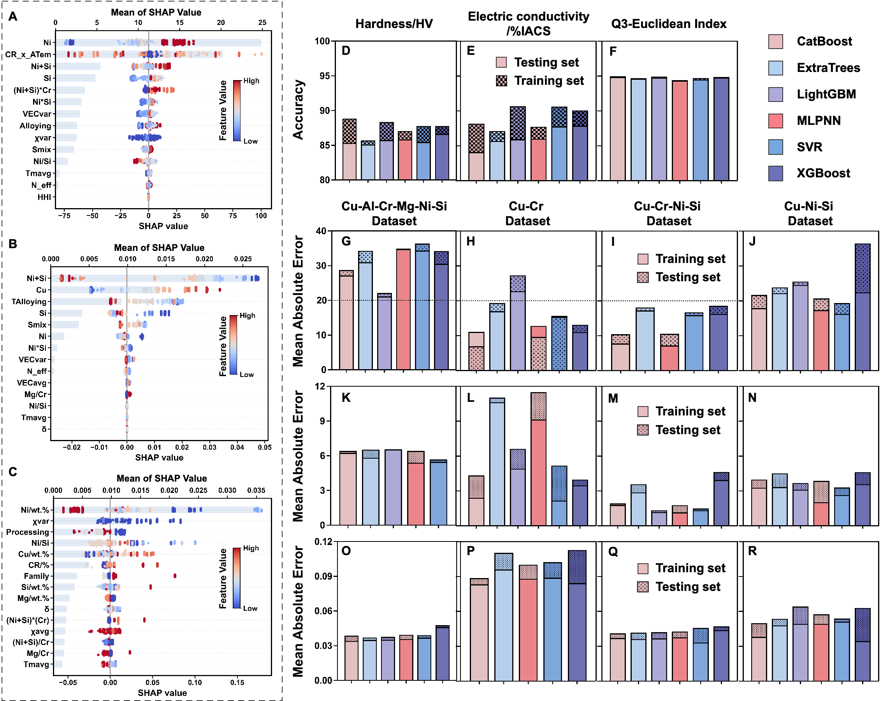
Fig. 7. SHAP feature interpretation and ML prediction performance for representative copper alloy systems. (A–C) SHAP feature importance analysis for hardness, electrical conductivity, and Q3-Euclidean. (D–F) Prediction accuracy of different machine-learning models across Cu–Ni–Si–Al–Cr–Mg, Cu–Cr, Cu–Cr–Ni–Si, and Cu–Ni–Si datasets using an 80:20 train–test split. (G–R) Mean absolute error (MAE) comparison for hardness, electrical conductivity, and Q3-Euclidean prediction across different alloy systems and models.

5.2 CPSP-Guided Experimental Validation and Microstructural Mechanism Analysis
Representative Cu–Ni–Si–Cr alloys optimized through the CPSP-guided machine-learning framework were experimentally fabricated and systematically characterized. As shown in Fig. 8A–B, both optimized Cu–Ni–Si–Cr alloys exhibited typical precipitation-hardening behavior during aging treatment. At 450 °C, hardness increased gradually without obvious over-aging-induced softening, indicating relatively sluggish precipitation kinetics. When the aging temperature increased to 460 °C, a typical peak-aging response was observed, with hardness rapidly increasing to a maximum at approximately 20–30 min before gradually decreasing. Further increasing the temperature to 475 °C significantly accelerated both hardening and over-aging due to enhanced precipitate nucleation, growth, and coarsening kinetics. Meanwhile, electrical conductivity continuously increased with aging time under all aging conditions, mainly owing to the depleti-
on of supersaturated solute atoms from the Cu matrix during precipitation.
As shown in Table 2, under the optimized peak-aged condition of 460 °C for approximately 20–30 min, the Cu–5.8Ni–0.95Si–0.12Cr alloy achieved 369 HV, 23.81 %IACS, 1097 MPa tensile strength, and ~5% elongation. The Cu–5Ni–1.5Si–0.25Cr alloy exhibited further improved properties, reaching 375 HV, 25.27 %IACS, 1133 MPa tensile strength, and ~8% elongation.The corresponding prediction results showed good agreement with the experimental measurements, with hardness prediction errors remaining within ~6% and electrical conductivity prediction errors of 4.75% and 13.37% , for the Cu–5.8Ni–0.95Si–0.12Cr and Cu–5Ni–1.5Si–0.25Cr alloys, respectively. The larger deviation in electrical conductivity can be attributed to its stronger sensitivity to microstructure-dependent electron-scattering sources, such as residual solute atoms, precipitate distribution, dislocation density, and interfacial structures, which are difficult to fully describe using current CPSP framework [2,28–29]. The engineering stress–strain curves in Fig. 8C demonstrate the favorable strength–conductivity–ductility balance of the optimized alloys. Compared with Cu–5.8Ni–0.95Si–0.12Cr, Cu–5Ni–1.5Si–0.25Cr exhibited simultaneously improved strength and ductility, which can be attributed to its optimized precipitation state and Ni/Si ratio.
Table 2 Experimental validation of experimental and predicted properties of peak-aged Cu alloys
Alloy | Processing-Route | Experimental Value  (Peak-Aged State) |  | Prediction (Error %)
 |  | Hardness  /HV | Electricial Conductivity  /%IACS | Hardness  /HV | Electricial Conductivity  /%IACS
Cu-5.8Ni-0.9Si-0.12Cr | Homo 960℃/4h → HR 80% → ST 980℃/4h → CR 50% → Aging | 369 | 23.81 | 346  (6.23%) | 24.94  (4.75%)
Cu-5Ni-1.5Si-0.25Cr | Homo 960℃/4h → HR 80% → ST 980℃/4h → CR 50% → Aging | 375 | 25.27 | 352  (6.13%) | 28.65  (13.37%)
Notes: Homo =homogenization treatment; HR = hot rolling; ST = solution treatment; CR = cold rolling; Aging = aging treatment.

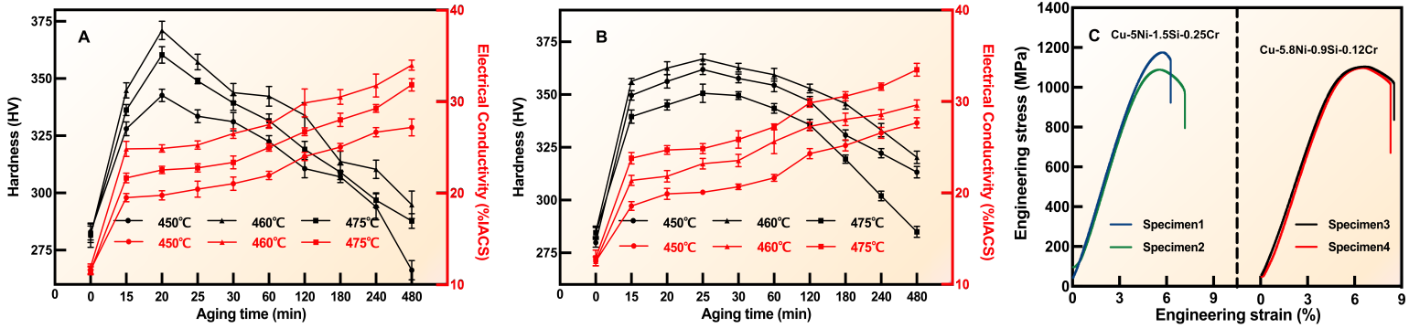
Fig. 8. Experimental validation of CPSP-guided Cu–Ni–Si–Cr alloy design. (A–B) Aging hardness and electrical conductivity evolution curves of Cu–5.8Ni–0.95Si–0.12Cr and Cu–5Ni–1.5Si–0.25Cr alloys under different aging temperatures. (C) Engineering stress–strain curves of representative peak-aged Cu–Ni–Si–Cr alloys. The results demonstrate the strength–conductivity–ductility balance achieved through CPSP-guided alloy optimization.

Fig. 9 presents the TEM and STEM characterization results of the peak-aged Cu–Ni–Si–Cr alloy after cold deformation. As shown in the Fig. 9a, a high density of dislocation tangles and dislocation walls was retained in the Cu matrix after aging, suggesting that deformation-induced substructures were only partially recovered during peak-aging treatment. These retained substructures may contribute to dislocation/ substructure strengthening and are likely associated with preferential precipitation of Ni-Si-rich phases [8, 28]. These observations are consistent with a deformation-assisted precipitation process, resulting in a heterogeneous microstructure composed of dislocation walls, nanoscale precipitates, and locally recovered or recrystallized regions. The HRTEM image in Fig. 9b reveals fine precipitates embedded in Cu matrix, while the corresponding FFT pattern in Fig. 9c supports their crystallographic identification. Further crystallographic analysis of a representative precipitate, shown in Fig. 9e and f, indicates the following orientation relationship:
$$\text{[110] }\text{Cu}\text{ // [11}\text{2}\text{] }{\text{Ni}}_{\text{2}}\text{Si}$$
This relationship suggests a specific lattice correspondence between the Cu matrix and the Ni₂Si precipitate.
Such an orientation relationship may indicate a coherent or semi-coherent interfacial configuration, which is favorable for maintaining a fine precipitate dispersion during aging. The nanoscale precipitates are therefore expected to contribute to precipitation strengthening through interactions with gliding dislocations [7]. The bright-field TEM image in Fig. 9d further demonstrates the coexistence of retained dislocation walls, nano-scale precipitates, and locally recovered/recrystallized regions. The persistence of dense deformation sub-structures indicates incomplete recrystallization, whereas the presence of fine precipitates suggests that precipitation may retard dislocation recovery and sub-boundary migration, thereby suppressing excessive recovery and grain/subgrain coarsening. The HAADF-STEM image and STEM-EDS elemental maps in Fig. 9g and h show a relatively uniform distribution of Ni and Si, without obvious coarse segregation or continuous grain-boundary precipitation. This relatively homogeneous precipitation state is beneficial for both mechanical strengthening and electrical transport, as precipitation removes Ni and Si solutes from the Cu matrix and reduces solute-related electron scattering. The precipitate size distribution in Fig. 9i shows that the Ni₂Si precipitates have an average size of approximately 4.39 nm, with most particles distributed within the range of 3–5 nm. This narrow size distribution and limited coarsening are characteristic of a peak-aged state with high precipitate density. Therefore, the enhanced strength of the alloy originates from combined effects of retained deformation substructures and finely dispersed Ni₂Si precipitates, while the improved conductivity is associated with solute depletion from the Cu matrix during precipitation [2-3]. The microstructural evidence in the Fig.9 therefore provides mechanistic support for the strength–conductivity synergy achieved through CPSP-guided alloy design.
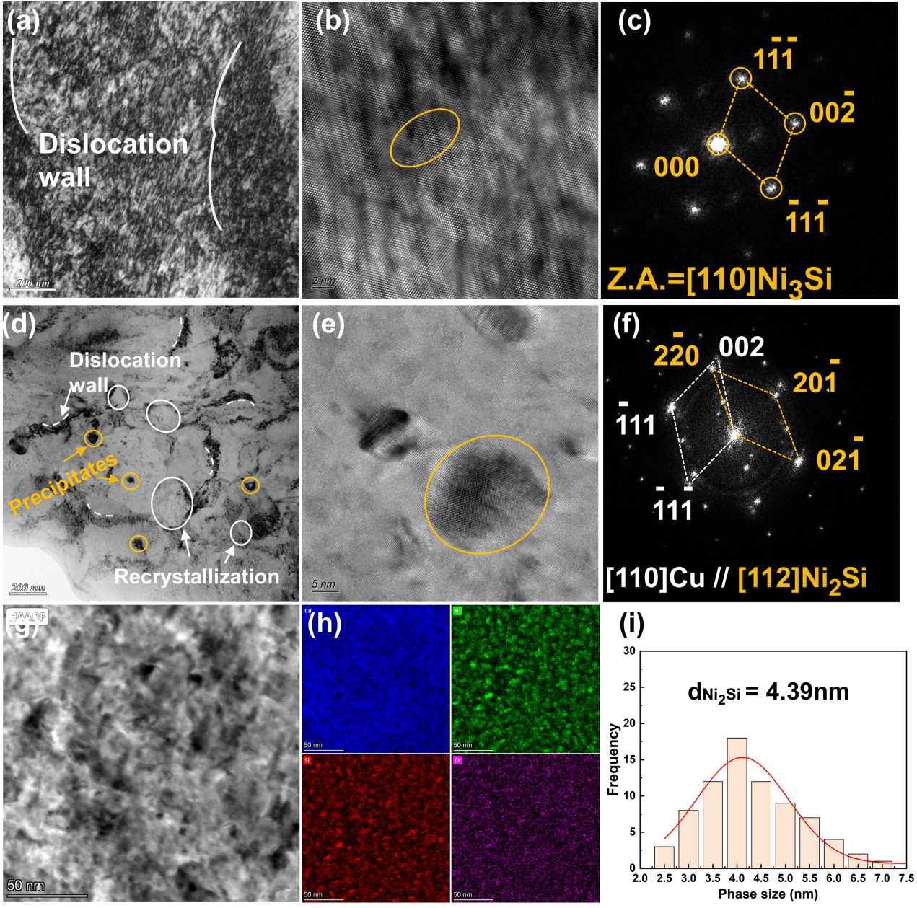
Fig. 9. TEM/STEM characterization and precipitation analysis of the peak-aged Cu–Ni–Si–Cr alloy after cold deformation. (a) Low-magnification TEM image showing retained high-density dislocation sub-structures and dislocation walls in the deformed Cu matrix. (b) HRTEM image of nanoscale precipitates embedded in the Cu matrix. (c) Corresponding FFT pattern of the precipitate marked in (b), indexed as Ni₃Si viewed along the [110] zone axis.(d) Bright-field TEM image showing the coexistence of dislocation walls, nanoscale precipitates, and locally recrystallized regions. (e) HRTEM image of a representative nanoscale precipitate in the matrix. (f) Corresponding SAED/FFT pattern revealing the crystallographic relationship between the Cu matrix and Ni₂Si precipitate, with [110]Cu//[112]Ni₂Si. (g) HAADF-STEM image of the aged microstructure. (h) STEM-EDS elemental maps of Cu, Ni, Si, and Cr, showing the elemental distribu-tion in the observed region. (i) Size distribution of Ni₂Si precipitates, showing an average precipitate size of approximately 4.39 nm.
Discussions
The proposed framework provides a literature-centric knowledge organization strategy for copper alloy informatics. Conventional data-driven materials research is often dataset-centered, relying on manual literature collection and static dataset construction prior to machine-learning modeling. While such work-flows are effective for property prediction and alloy optimization, they provide limited support for under-standing the broader research landscape and knowledge evolution within a field [43-45]. In contrast, the proposed Corpus–Topic–Document framework enables systematic exploration of research activities and evolving trends across publishers, journals, institutions, funding agencies, and research themes (Supplemen-tary Figure 1), providing valuable insights for research planning and identification of emerging opportunities. Combined with document-level CPSP reconstruction, the framework establishes a unified pathway linking research landscape analysis, knowledge organization, and data-driven alloy discovery, thereby shifting alloy informatics from static dataset development toward reusable knowledge infrastructure construction.
Within this framework, CPSP resources can be dynamically reorganized by alloy system, target property, and metallurgical task, enabling task-oriented dataset generation from a unified knowledge infra-structure rather than repeated construction of alloy-specific databases. In this sense, the CTD framework provides a unified pathway from scientific literature to alloy discovery by converting literature from a passive information source into a reusable knowledge infrastructure. Because the resulting repositories are machine-readable, semantically organized, and dynamically reconfigurable, they may also provide a foundation for future AI agents and autonomous scientific workflows [46].
Despite these advances, several limitations remain. First, the current framework should be interpreted within the scope of repository-level integration. Textual, tabular, and figure-derived information are primarily linked through shared metadata, such as DOI, alloy system, composition, processing route, and performance descriptors, rather than through fully automated entity-level alignment. Consequently, the reconstructed CPSP chains represent coordinated organization of heterogeneous knowledge sources rather than complete cross-modal semantic fusion. While text- and table-based CPSP reconstruction has achieved relatively high reliability, image-derived information is currently used mainly for figure categorization and repository organization. Quantitative extraction of structural descriptors, such as grain size, precipitate characteristics, dislocation density, and texture information, remains limited. Consequently, the current framework is more effective for composition-, processing-, and property-related information than for fine-grained structural knowledge reconstruction. In addition, downstream machine-learning validation was based on randomly partitioned datasets. Although duplicate records were removed and comparable processing routes were selected, latent correlations among literature-derived records may still affect model generalizability. Future efforts may focus on more rigorous validation strategies, quantitative image understanding, and entity-level cross-modal alignment [49–50]. These developments would further enhance the capability of the Corpus–Topic–Document framework to transform scientific literature into actionable knowledge resources, providing a scalable pathway from scientific literature to alloy discovery.
Conclusions
In this work, a Corpus–Topic–Document (CTD) framework was developed to transform fragmented scientific literature into machine-readable CPSP knowledge resources for copper alloy informatics. Through corpus-level semantic filtering, topic-level knowledge organization, and document-level CPSP reconstruc-tion, the framework establishes a hierarchical pathway for organizing and utilizing literature knowledge from coarse-grained corpus understanding, through intermediate-grained topic organization, to fine-grained CPSP reconstruction.The framework demonstrated the capability to reconstruct high-quality CPSP resources from large-scale literature and support reliable multi-modal knowledge extraction across textual, tabular, and graphical information sources.The reconstructed CPSP resources were further utilized for machine-learning-guided alloy design and experimental validation, demonstrating their practical value for data-driven copper alloy development. Microstructural characterization further confirmed that the optimized alloy performance originated from coupled deformation–precipitation interactions. More importantly, this work shifts alloy informatics from static dataset construction toward literature-centric knowledge infrastructure development, enabling dynamic CPSP resource organization, task-oriented dataset generation, and reusable knowledge support for alloy discovery. Ultimately, the proposed Corpus–Topic–Document framework provides a scal-able pathway for transforming scientific literature into actionable knowledge resources, bridging scientific literature and alloy discovery through reusable CPSP knowledge infrastructures.
Data availability
The data and code used in this study can be found on the GitHub via: https://github.com/zhaozixuan6678/ Copper-CPSP-infrastructure
Acknowledgements
The authors acknowledge the financial supports by the Advanced Materials-National Science and Technology Major Project (Grant No. 2025ZD0612100), the National Natural Science Foundation of China (Grant No. 52371038), the Science and Technology Innovation Program of Hunan Province (2023RC1019), and the High-Performance Computing Center of Central South University.
Author Contributions
Zixuan Zhao: Conceptualization, Data curation, Coding, Visualization, Modeling, Writing-original draft. Zhikang Xie: Data curation, Experimental Validation. Fei Tan: Experimental Validation, Data analysis, Peiyun Chen, Xiang Liu, Wenqin Xu, Tianze Hu: Experimental Validation. Weimin Wu, Yanpeng Ye, Wei Chen: Modeling. Byungju Lee, Tong Xie, Guofu Xu: Writing-review. Yanbin Jiang, Zhou Li: Resources, Project administration, Funding acquisition, Supervision.
- References：
- Wilkinson MD, Dumontier M, Aalbersberg IJ, Appleton G, Axton M, Baak A, et al., 2016. The FAIR Guiding Principles for scientific data management and stewardship. Scientific Data. 3, 160018. https://doi.org/10.1038/ sdata.2016.18.
- Yang H, Ma Z, Lei C, Meng L, Fang Y, Liu J, et al., 2020. High strength and high conductivity Cu alloys: A review. Science China Technological Sciences. 63, 2505-17. https://doi.org/10.1007/s11431-020-1633-8.
- Gorsse S, Ouvrard B, Gouné M, Poulon-Quintin A, 2015. Microstructural design of new high conductivity-high strength Cu-based alloy. Journal of Alloys and Compounds. 633, 42-7. https://doi.org/https://doi.org/10.1016/j. jallcom.2015.01.234.
- Wu C, Liao M, Zhou X, Chen J, Qian X, Wang Y, et al., 2026. Exploring the Pareto front of strength-conductivity trade-off: interpretable machine learning for property prediction and composition design in high-strength high-conductivity Cu alloys. Journal of Materials Informatics. 6, 6.
- Zhang H, Fu H, He X, Wang C, Jiang L, Chen L-Q, et al., 2020. Dramatically Enhanced Combination of Ultimate Tensile Strength and Electric Conductivity of Alloys via Machine Learning Screening. Acta Materialia. 200, 803-10. https://doi.org/https://doi.org/10.1016/ j.actamat.2020.09.068.
- Wang C, Fu H, Jiang L, Xue D, Xie J, 2019. A property-oriented design strategy for high performance copper alloys via machine learning. npj Computational Materials. 5, 87. https://doi.org/10.1038/s41524-019-0227-7.
- Qin Z, Zhao H, Zhang S, Fan Y, Dong X, Lan Z, et al., 2024. Design of high performance Cu-Ni-Si alloys via a multiobjective strategy based on machine learning. Materials Today Communications. 39, 108833. https://doi.org/ https://doi.org/10.1016/j.mtcomm.2024.108833.
- Jiang L, Fu H, Wang C, Li W, Xie J, 2019. Enhanced Mechanical and Electrical Properties of a Cu-Ni-Si Alloy by Thermo-mechanical Processing. Metallurgical and Materials Transactions A. 51, 331-41. https://doi.org/10.1007/ s11661-019-05507-3.
- Yi J, Jia Y, Zhao Y, Xiao Z, He K, Wang Q, et al., 2019. Precipitation behavior of Cu-3.0Ni-0.72Si alloy. Acta Materialia. 166, 261-70. https://doi.org/https://doi.org/10.1016/ j.actamat.2018.12.047.
- Choi J, Lee B, 2024. Accelerating materials language processing with large language models. Communications Materials. 5, 13. https://doi.org/10.1038/s43246-024-00449-9.
- Xie T, Wan Y, Huang W, Zhou Y, Liu Y, Linghu Q, et al., 2023. Large Language Models as Master Key: Unlocking the Secrets of Materials Science with GPT. ArXiv. abs/2304.02213,
- Gupta T, Zaki M, Krishnan NMA, Mausam, 2022. MatSciBERT: A materials domain language model for text mining and information extraction. npj Computational Materials. 8, 102. https://doi.org/10.1038/s41524-022-00784-w.
- Zhao Z, Tan F, Xie T, Chen W, Yu J, Ye Y, et al., 2026. Automated distillation of composition–processing–structure–performance linkages from fragmented and multi-modal materials literature. Materials & Design. 267, 116250. https://doi.org/https://doi.org/10.1016/j.matdes.2026.116250.
- Choi J, Lee B, 2024. Quantitative Topic Analysis of Materials Science Literature Using Natural Language Processing. ACS Appl Mater Interfaces.16,1957-68. https://doi.org/10. 1021/acsami.3c12301.
- Grootendorst MR, 2022. BERTopic: Neural topic modeling with a class-based TF-IDF procedure. ArXiv. abs/2203.05794,
- McInnes L, Healy J, 2018. UMAP: Uniform Manifold Approximation and Projection for Dimension Reduction. ArXiv. abs/1802.03426,
- Yun P, Fu H, Zhang H, Jiang L, Xiao X, Zhu S, et al., 2025. Mechanical and Electrical Properties dataset of Cu-Cr-X alloys generated with automated figure data extraction. Scientific Data. 12, 2023. https://doi.org/10.1038/ s41597-025-06295-9.
- Gorsse S, Gouné M, Lin W-C, Girard L, 2023. Dataset of mechanical properties and electrical conductivity of copper-based alloys. Scientific Data. 10, 504. https://doi.org/10. 1038/s41597-023-02411-9.
- Ding X, Li Y, Chen S, 2024. Maximum margin and global criterion based-recursive feature selection. Neural Networks. 169, 597-606. https://doi.org/https://doi.org/10.1016/j. neunet.2023.10.037.
- Zhang S, Wang WY, Wang X, Li G, Ren Y, Gao X, et al., 2024. Large language models enabled intelligent microstructure optimization and defects classification of welded titanium alloys. Journal of Materials Informatics. 4, 34.
- Miret S, Krishnan NMA, 2025. Enabling large language models for real-world materials discovery. Nature Machine Intelligence. 7, 991-8. https://doi.org/10.1038/s42256-025-01058-y.
- Liu N, Jafarzadeh S, Lattimer BY, Ni S, Lua J, Yu Y, 2025. Harnessing large language models for data-scarce learning of polymer properties. Nature Computational Science. 5, 245-54. https://doi.org/10.1038/ s43588-025-00768-y.
- Blei DM, Ng AY, Jordan MI, 2003. Latent dirichlet allocation. J Mach Learn Res. 3, 993-1022.
- Polak MP, Morgan D, 2024. Extracting accurate materials data from research papers with conversational language models and prompt engineering. Nature Communications. 15, 1569. https://doi.org/10.1038/s41467-024-45914-8.
- Boiko DA, MacKnight R, Kline B, Gomes G, 2023. Autonomous chemical research with large language models. Nature. 624, 570-8. https://doi.org/10.1038/s41586-023-06792-0.
- Wang S, Wan Y, Song N, Liu Y, Xie T, Hoex B, 2024. Automatically Generated Datasets: Present and Potential Self-Cleaning Coating Materials. Scientific Data.11,146. https: //doi.org/10.1038/s41597-024-02983-0.
- Yi GH, Choi J, Song H, Miano O, Choi J, Bang K, et al., 2025. MaTableGPT: GPT-Based Table Data Extractor from Materials Science Literature (Adv. Sci. 16/2025). Advanced Science. 12, 2570114. https://doi.org/https://doi.org/ 10.1002/advs. 202570114.
- Fu H, Zhang Y, Zhang M, Yun X, 2023. Microstructure evolution, precipitation behavior, and mechanical properties of continuously extruded Cu-Ni-Si alloys at different aging treatments. Journal of Materials Processing Technology. 317,117986. https://doi.org/https://doi. org/10.1016/j.jmatprotec.2023.117986.
- Jiang Yb, Zhang Tt, Lei Y, Liu Xh, Cao Y, Xie Jx, et al., 2020. Microstructure evolution and mechanical properties of Cu-0.36Be-0.46Co alloy fabricated by heating-cooling combin-ed mold horizontal continuous casting during cold rolling. Transactions of Nonferrous Metals Society of China. 30, 958-71. https://doi.org/https://doi.org/ 10.1016/S1003-6326(20)65268-2.
- Lu X, Luo S, Li J, Chen M, Yao T, Xu Z, et al., 2025. FIND: a forward-inverse navigation and discovery platform for hydrogen storage alloys powered by data-driven machine learning. Journal of Materials Informatics. 5, 48.
- Yoshizawa T, Ishida S, Sato T, Ohta M, Honma T, Terayama K, 2025. A data-driven generative strategy to avoid reward hacking in multi-objective molecular design. Nature Communications. 16, 2409. https://doi.org/10.1038/ s41467-025-57582-3.
- Yao T, Huang J, Yan Y, Yang Y, Wang Z, Shao X, et al., 2025. From large language models to AI agents in energy materials research: enabling discovery, design, and automation. AI Agent. 1, 9.
- Wang G, Peng L, Li K, Zhu L, Zhou J, Miao N, et al., 2021. ALKEMIE: An intelligent computational platform for accelerating materials discovery and design. Computational Materials Science. 186, 110064. https: //doi.org/https://doi.org/10.1016/ j.commatsci.2020. 110064.
- Wang Y, Wang F, Yan G, Wang J, Niu G, Feng J, et al., 2025. MatSci-ML Studio: an interactive workflow toolkit for automated machine learning in materials science. Journal of Materials Informatics. 5, 51.
- Wang X, Zeng Q, Xu D-H, Zhang L, Jiang G, Yang M, 2026. Accelerating materials discovery via AI-Agent integration of large language models and simulation tools. Journal of Materials Informatics. 6, 9.
- Tan F, Zhao Z, Jiang Y, Zhang W, Xie T, Chen W, et al., 2026. Dual Engine-driven Strategy for Advanced Copper Alloy Design employing Large Language Models. Acta Materialia. 306, 121886. https://doi.org/10.1016/ j.actamat.2025.121886.
- Barbieri MC, Grisci BI, Dorn M, 2024. Analysis and comparison of feature selection methods towards performance and stability. Expert Systems with Applications. 249, 123667. https://doi.org/https://doi.org/10. 1016/j.eswa.2024.123667.
- Zhong X, Gallagher B, Liu S, Kailkhura B, Hiszpanski A, Han TY-J, 2022. Explainable machine learning in materials science. npj Computational Materials. 8, 204. https://doi.org/ 10.1038/s41524-022-00884-7.
- Chen W, Zheng H, Jiang Y, Tan F, Wang M, Lei Q, et al., 2026. Data-augmented machine learning design and performance-enhancing quaternary synergistic mechanism of novel Cu-Be alloy. npj Computational Materials. https://doi.org/10.1038/s41524-026-02000-5.
- Chen W, Jiang Y-B, Tan F, Zhao Z-X, Ma M-Z, Wang M, et al., 2025. Design of high-performance Cu-Be alloy based on machine learning with integrated phase diagram information. Rare Metals. 44, 5824-43. https://doi.org/ 10.1007/s12598-025-03331-w.
- Rao Z, Tung P-Y, Xie R, Wei Y, Zhang H, Ferrari A, et al., 2022. Machine learning-enabled high-entropy alloy discovery.Science.378,78-85.https://doi.org/doi:10.1126/ science. abo4940.
- Junhao Y, Zhen L, Yujia Y, Anyi Y, Wenjie L, Dan S, et al., 2024. Applications of machine learning method in high-performance materials design: a review. Journal of Materials Informatics. 4, 14.
- Xiang J, Li Y, Zhang X, He Y, Sun Q, 2025. Local large language model-assisted literature mining for on-surface reactions. Materials Genome Engineering Advances. 3, e88. https://doi.org/https://doi.org/10.1002/ mgea.88.
- Lu Z, Kapoor I, Araki T, Chen L, Song T, Li Y, et al., 2026. Semantic Intelligence in Metallurgy: A Dual-Stage Language Model Framework for Processing-Aware Magnesium Alloy Design. Materials Genome Engineering Advances. 4, e70056. https://doi.org/https://doi.org/10.1002/mgea.70056.
- Jin X, Luo H, Wang X, Cheng H, Fan C, Li X, et al., 2024. Data mining accelerated the design strategy of high-entropy alloys with the largest hardness based on genetic algorithm optimization. Materials Genome Engineering Advances. 2, e49. https://doi.org/https://doi.org/10.1002/mgea.49.
- Ma J, Cao B, Dong S, Tian Y, Wang M, Xiong J, et al., 2024. MLMD: a programming-free AI platform to predict and design materials. npj Computational Materials. 10, 59. https://doi.org/10.1038/s41524-024-01243-4.
- Zhang B, Li X, Xu H, Jin Z, Wu Q, Li C, 2026. TopoMAS: Large Language Model Driven Topological Materials Multi-Agent System. Materials Genome Engineering Advances. 4, e70045. https://doi.org/https://doi. org/10.1002 /mgea.70045.
- Wang WY, Zhang S, Li G, Lu J, Ren Y, Wang X, et al., 2024. Artificial intelligence enabled smart design and manufacturing of advanced materials: The endless Frontier in AI+ era. Materials Genome Engineering Advances. 2, e56. https://doi.org/https://doi.org/10.1002/mgea.56.
- Jiang M, AitTamerd M, He Z, Bi W, Zhao M, Li S, et al., 2026. MatImageAgent: A Large Language Multimodal Agent for Materials Characterization Images. Materials Genome Engineering Advances. n/a, e70058. https://doi.org/ https://doi.org/10.1002/mgea.70058.
- Han S, Wang C, Zhang Y, Xu W, Di H, 2024. Employing deep learning in non-parametric inverse visuali-zation of elastic–plastic mechanisms in dual-phase steels. Materials Genome Engineering Advances. 2, e29. https://doi.org/ https://doi.org/10.1002/mgea.29.

